Joseph M. Furman, MD, PhD, FAAN
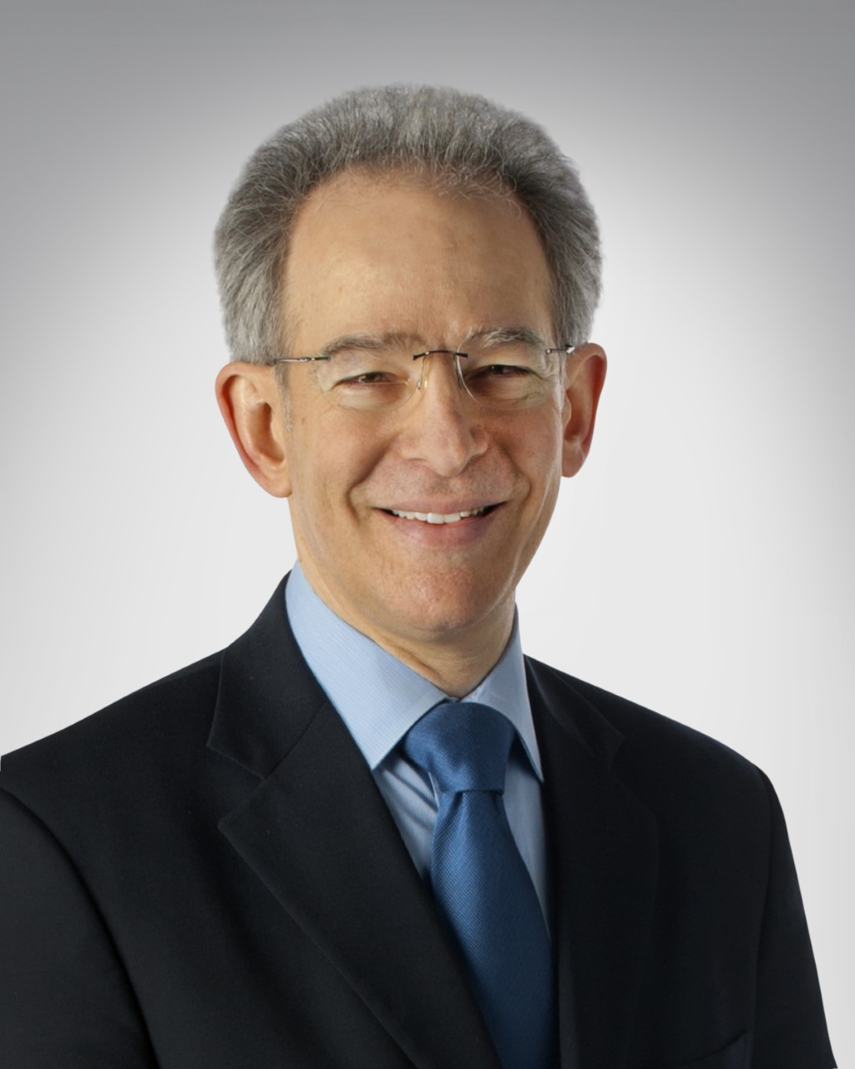
Joseph Furman is a Professor in the Departments of Otolaryngology, Neurology, Bioengineering, and Physical Therapy at the University of Pittsburgh and director of the division of balance disorders at the University of Pittsburgh Medical Center. His education includes an M.D. and a Ph.D. in Bioengineering from the University of Pennsylvania, a residency in neurology at UCLA, and a fellowship in non-surgical otology at the University of Toronto. Dr. Furman's area of expertise is vestibular function and balance disorders. Dr. Furman is a board certified neurologist, a fellow of the American Academy of Neurology and a member of the American Neurological Association. Dr. Furman's clinical activities include the evaluation of patients with dizziness and disequilibrium and consultation neurology. Dr. Furman's research interests include vestibulo-ocular function in older persons, otolith-ocular reflexes, and migraine-related dizziness. Dr. Furman has received several NIH grants in these research areas and has published over 180 referred articles.

David S. Zee, MD
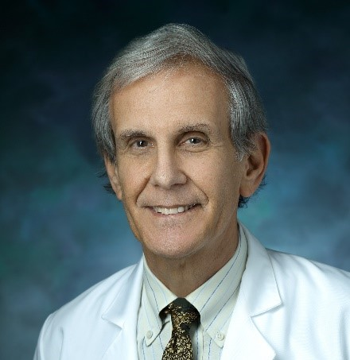
Dr. Zee began his scientific career at The Johns Hopkins University in 1965 as a medical student, completed his neurology residency there, and has been a member of the Johns Hopkins family for 55 years. He has a special interest in vision and eye movements, cerebellar function, and vestibular disorders. He has been a full professor since 1985 and is now the Paul and Betty Cinquegrana Professor. He is coauthor of the textbook, The Neurology of Eye Movements with Dr. R. John Leigh, with the fifth edition published in 2015, and he has published about 500 papers. Among his honors he received the Ottorino Rossi Prize from the University of Pavia in Italy, the Koetser Foundation Brain Research Prize in Zurich, the Johns Hopkins (Abeloff) Lifetime Achievement Award in Medical and Biomedical Education and the Hallpike-Nylen Medal and the Bárány Gold Medal from the Barany Society in Sweden.

Michelle R. Petrak, PhD, PhD, CCC-A
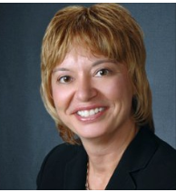
Dr. Michelle Petrak is the Director of Clinical Audiology and Vestibular Research for Interacoustics. Her primary role is development and clinical validation of new technologies in the vestibular and balance areas. She is located in Chicago where she is a licensed private practice clinical audiologist at Northwest Speech and Hearing (NWSPH). Dr. Petrak received her doctorates in Electrophysiology (1992) and Biomolecular Electronics (1994) from Wayne State University and her Masters in Audiology in 1989. Her special areas of expertise include vestibular and balance assessments and management of the dizzy patient Dr. Petrak is involved with new innovative product developments, clinical evaluations of new protocols, and publishing, teaching and training on the management of patients with dizziness. She continues to lecture extensively nationally and internationally and she has numerous articles published in the hearing industry journals. She also participates on the committees for several doctoral students as support for the research projects.

Terry D. Fife, MD
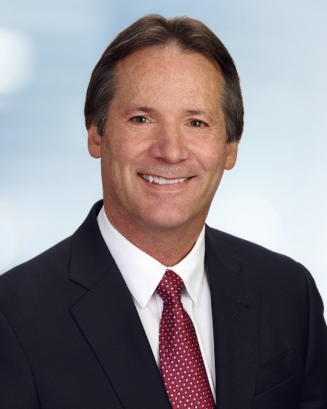
Dr. Terry Fife is the Director of the Otoneurology and Balance Disorders Program and the Director of Graduate Medical Education (DIO) at Barrow Neurological Institute in Phoenix. He is a Professor of Neurology at the University of Arizona College of Medicine and is board certified in both internal medicine and in neurology. Dr. Fife graduated from University of Arizona magna cum laude, Phi Beta Kappa and Phi Kappa Phi with Honors in Chemistry. He graduated from Texas A&M University College of Medicine then completed internal medicine residency training at the University of California, Davis and then trained in neurology at UCLA followed by a fellowship also at UCLA. He specializes otoneurology and has published numerous articles on the topics of vertigo, disorders of balance and equilibrium including cerebellar ataxia, chronic imbalance, hydrocephalus, recurrent falling and syncope.

Catherine V. Palmer, PhD
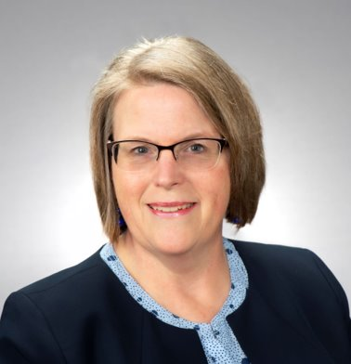
Catherine Palmer is Professor in the Department of Communication Science and Disorders at the University of Pittsburgh and serves as the Director of Audiology for the UPMC Integrated Health System. Dr. Palmer conducts research in the areas of auditory learning post hearing aid fitting, the relationship between hearing, cognitive health and health outcomes, and matching technology to individual needs. She has published over 100 articles and book chapters in these topic areas as well as provided over 200 national and international presentations. Dr. Palmer teaches the graduate level amplification courses at the University of Pittsburgh, serves as Editor-in-Chief of Seminars in Hearing, and currently serves as the Past President of the American Academy of Audiology 2019-2020. She was named Interim Chair of the Department of Communication Science and Disorders at the University of Pittsburgh in June of 2022.

Susan L. Whitney, DPT, PhD, NCS, ATC, FAPTA
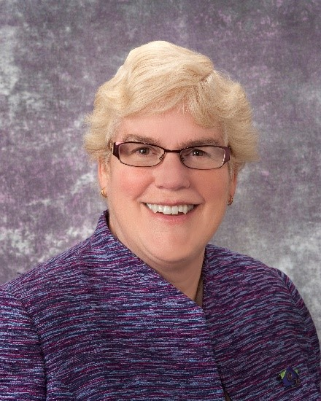
Susan L. Whitney, DPT, PhD, NCS, ATC, FAPTA received her PhD in motor development/motor learning from the University of Pittsburgh and her professional physical therapy education from Temple University in Philadelphia, PA. Currently, she is a professor in physical therapy in the School of Health and Rehabilitation Sciences, in the Department of Otolaryngology and the Center for Clinical and Translational Sciences at the University of Pittsburgh. Dr. Whitney is supported by the Department of Defense to develop technology for persons with vestibular disorders and to study exercise dosage. Dr. Whitney has authored or coauthored over 160 articles on Medline and is currently engaged in research related to concussion and persons with balance and vestibular disorders.

Jorge C. Kattah, MD
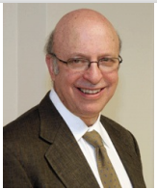
Jorge C Kattah, M.D., FAAN. Received the M.D. form El Colegio Mayor de Neustria Senora Del Rosario, School of Medicine in Bogota, Colombia in 1972, followed by a residency in Neurology at Georgetown University I 9176 and fellowship at the University of Pittsburgh, at the Eye and Ear Hospital in Neuro-Ophthalmology. He became Professor of Neurology at Georgetown University and moved to the University Of Illinois College Of Medicine in Peoria as Professor and Head of Neurology and Neurosurgery in 1997. His research focus involves ocular motor function and vestibular medicine in neurologic disorders, particularly the acute vestibular syndrome in stroke, demyelinating diseases, Wernicke’s and mitochondrial disorders. He has over 150 peer review articles and is a co-investigator in the AVERT trial.

Vicky Stewart, PT, PhD
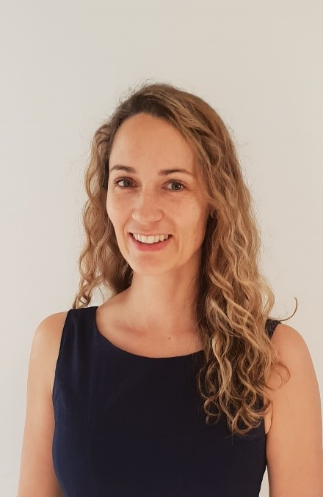
Vicky Stewart, BPHTY, PhD received her PhD in vestibular physiotherapy from the Australian Catholic University and her professional physiotherapy education from the University of Queensland, Australia. Currently, Dr. Stewart works as an advanced Physiotherapist at the Gold Coast University Hospital, functioning as a primary contact vestibular physiotherapist for ENT and Neurology services, and secondary contact management post hospital presentation for vestibular disorders. Vicky also works as a managing director at Advanced Vestibular Clinics. She has over 13 years clinical experience managing individuals with vestibular disorders including in the emergency department through to the outpatient setting. Dr. Stewart has authored or co-authored 7 articles and has presented at conferences nationally and internationally.

Britta Smith, DPT, NCS
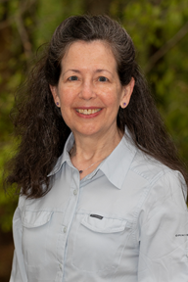
Britta Smith, PT, MMSc, DPT received her physical therapy degree from Medical College of Georgia and post-professional degrees from Emory University and A.T Still University. She is currently the Therapy Supervisor at Atlanta Medical Center in the Inpatient Rehabilitation Unit, but has also worked in both the acute care and out-patient departments. While she originally provided vestibular rehabilitation in an outpatient setting, her current interest is in the provision of services across the continuum of care, especially very early after the onset of symptoms. Dr. Smith is active in the Vestibular Rehabilitation Special Interest Group and is a historian for the Academy of Neurologic Physical Therapy.

Courtney D. Hall PT, PhD
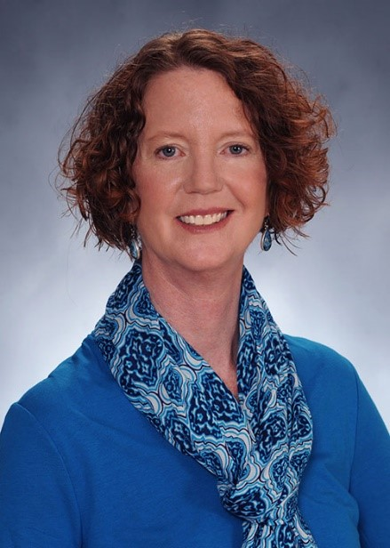
Dr. Hall received her Ph.D. in Kinesiology from the University of Texas at Austin and her professional physical therapy education from University of North Carolina at Chapel Hill. Currently she is a research health scientist at the Hearing and Balance Research Program at the Mountain Home VAMC and professor in the Physical Therapy Program at ETSU. Her clinic and research focus is towards understanding age-related changes in balance control and how best to intervene therapeutically to prevent loss of mobility and falls and reduce dizziness. Dr. Hall’s current research is funded through the Department of Veteran’s Affairs, Department of Defense and the National Institutes of Health, and seeks to develop novel rehabilitation interventions using technology to alleviate symptoms of dizziness and imbalance. Dr. Hall was the team lead for the Academy of Neurologic Physical Therapy’s original and the updated CPG on vestibular hypofunction.

Susan J. Herdman PT, PhD
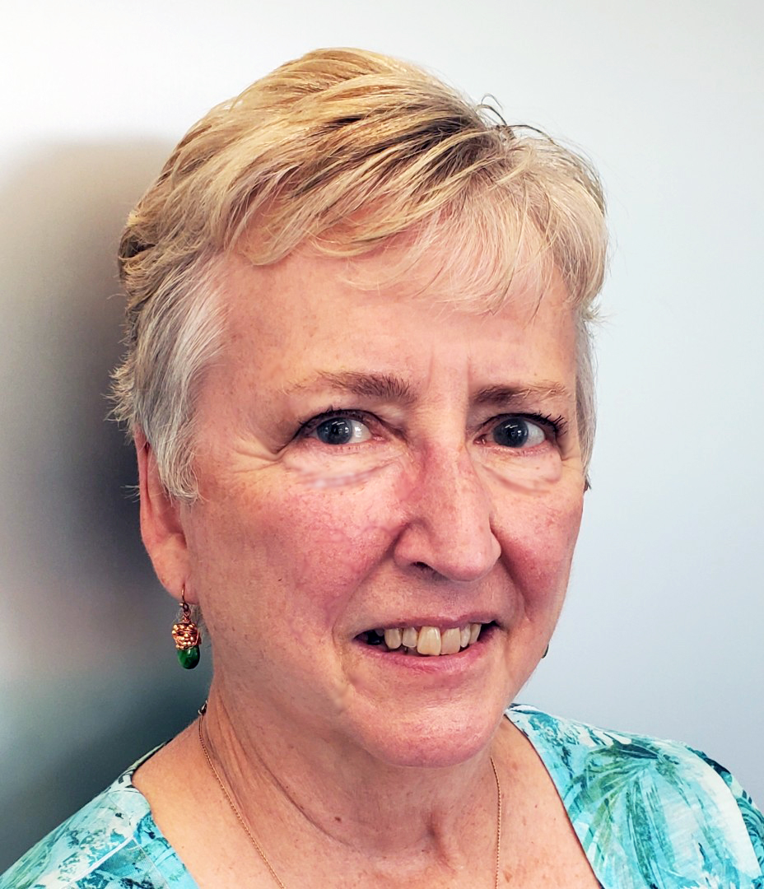
Susan J Herdman, PT, PhD received her PhD in neuroanatomy/anatomy from the University of Pennsylvania and her professional degree in physical therapy from the University of Pennsylvania. Currently she is Professor Emerita, Emory University School of Medicine, Department of Physical Medicine and Rehabilitation. Dr Herdman has received numerous grants, including from NIH, to support her work on the efficacy of exercises for individuals with vestibular deficits. She has authored or co-authored over 60 peer-reviewed articles, numerous chapters and several books including Vestibular Rehabilitation, now in its 4th edition. Although retired, her current research is focused on identifying factors that affect outcome in people with vestibular hypofunction and on reducing the redundancy of using multiple assessments in clinical practice.

Pamela M Dunlap PT, PhD, NCS
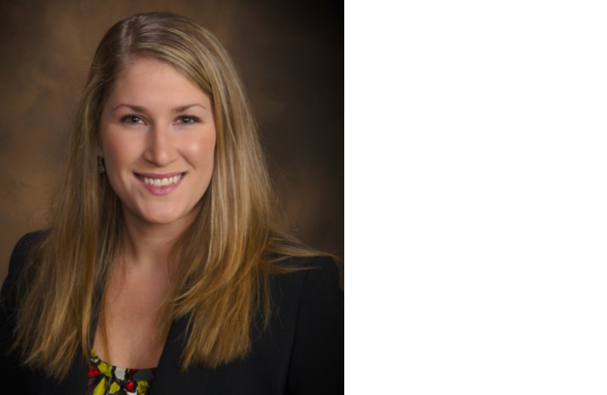
Pamela M. Dunlap, PT, DPT, PhD received her Doctor of Physical Therapy degree in 2011 and PhD in Rehabilitation Science in 2020 from the University of Pittsburgh. She has been a board certified Neurologic Clinical Specialist since 2015. Dr. Dunlap directed the UPMC Centers for Rehab Services Balance and Vestibular outpatient physical therapy clinic from 2012-2016 and has 10 years of experience treating individuals with balance and vestibular disorders. Her research interest is in outcome measurement and improving quality of care for persons with vestibular disorders. Dr. Dunlap is currently an Assistant Professor in the Department of Physical Therapy at the University of Pittsburgh. She has presented nationally and internationally including at the APTA Combined Sections Meeting, the Barany Society Meeting, and the annual course “Vestibular Rehabilitation: An Advanced Course and Update”.

Amy Cassidy, DPT, NCS
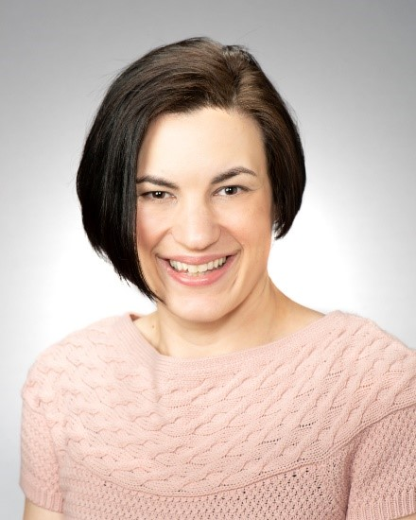
Amy R Cassidy PT, DPT, NCS received her Doctor of Physical Therapy degree in 2008 from Gannon University in Erie, PA. She became a Board Certified Neurologic Clinical Specialist in 2017. She is currently the Facility Director at UPMC Centers for Rehab Service Balance and Vestibular Clinic at UPMC Eye and Ear Institute. Dr. Cassidy was appointed as Adjunct Faculty for the University of Pittsburgh School of Health and Rehabilitation Sciences in 2021. She co-coordinated a Quality Improvement project to decrease the time of care from presentation in the ED with acute dizziness to being treated in outpatient physical therapy for UPMC. In addition to treating patients with vestibular/neurological diagnoses full time she is also the co-coordinator of EpicCare education for the Centers for Rehab Services organizing the training of electronic health record documentation within the company and is a staff physical therapist at the UPMC Critical Illness Recovery Center.

Yoon-Hee Cha, MD
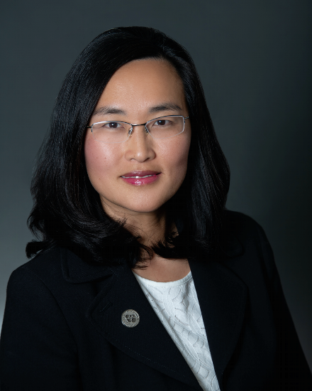
Dr. Yoon-Hee Cha is a Board certified Neurologist with subspecialty training in Neurotology. She is Associate Professor in the Department of Neurology at the University of Minnesota where she runs a research program using functional neuroimaging and non-invasive brain stimulation to study central neurological disorders such as mal de debarquement syndrome and other causes of persistent oscillating vertigo as well as the association between headache and vestibular symptoms. She has performed research using fMRI, PET, EEG, transcranial magnetic stimulation, and transcranial electrical current stimulation. She received her education from Stanford University, Mayo Medical School, Brigham and Women’s Hospital, the University of California San Francisco, and the University of California Los Angeles.

Carrie Hoppes, PT, PhD, NCS, OCS, ATC, CSCS
LTC Hoppes is an Associate Professor and Director of the Army-Baylor University DPT program. She graduated from Lock Haven University of Pennsylvania in 2003 (BS), the U.S. Army-Baylor University Doctoral Program in Physical Therapy in 2006 (DPT), and the University of Pittsburgh in 2017 (PhD). Her dissertation work utilized functional near-infrared spectroscopy to study the cerebral activation of individuals with visual vertigo during optic flow. Dr. Hoppes is a Board Certified Clinical Specialist in both Neurologic and Orthopaedic Physical Therapy, a Certified Athletic Trainer, and a Certified Strength and Conditioning Specialist. She has served as the Chief of Inpatient Physical Therapy and Amputee Physical Therapy at major military medical centers during the past 18 years. LTC Hoppes is also the co-founder of the Military Vestibular Assessment and Rehabilitation Course. She re-joined the Army-Baylor University DPT faculty in 2017. LTC Hoppes’ current teaching areas include Neurorehabilitation and Clinical Medicine III.

Anthony P. Kontos, PhD
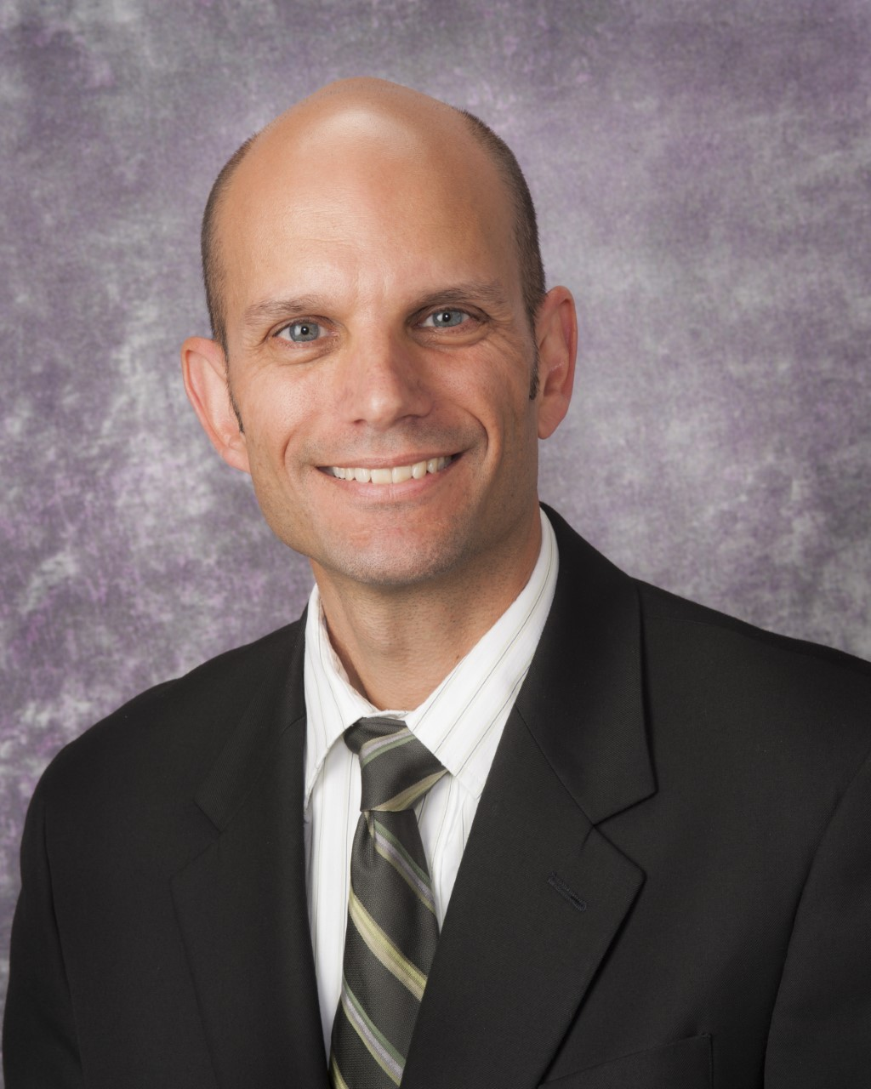
Dr. Anthony P. Kontos is Research Director for the UPMC Sports Medicine Concussion Program and Professor in the Departments of Orthopaedic Surgery and Sports Medicine and Rehabilitation at the University of Pittsburgh. He has specialized in concussion research for 17 years and has 343 professional publications and 325 professional presentations. His research is funded by the Centers for Disease Control and Prevention, Department of Defense, National Institutes of Health, and National Football League and focuses on active, precision treatments and clinical trials; risk factors; neurocognitive/neuromotor effects; psychological issues; and concussion in military, pediatric, and sport populations. Dr. Kontos is a fellow and past-president of the Society for Sport, Exercise & Performance Psychology, and a fellow of the National Academy of Kinesiology, Association for Applied Sport Psychology, and Eastern Psychological Association. He is also the lead co-author (with Dr. Collins) of Concussion: A Clinical Profile Based Approach to Assessment and Treatment.

Anne Mucha DPT, NCS
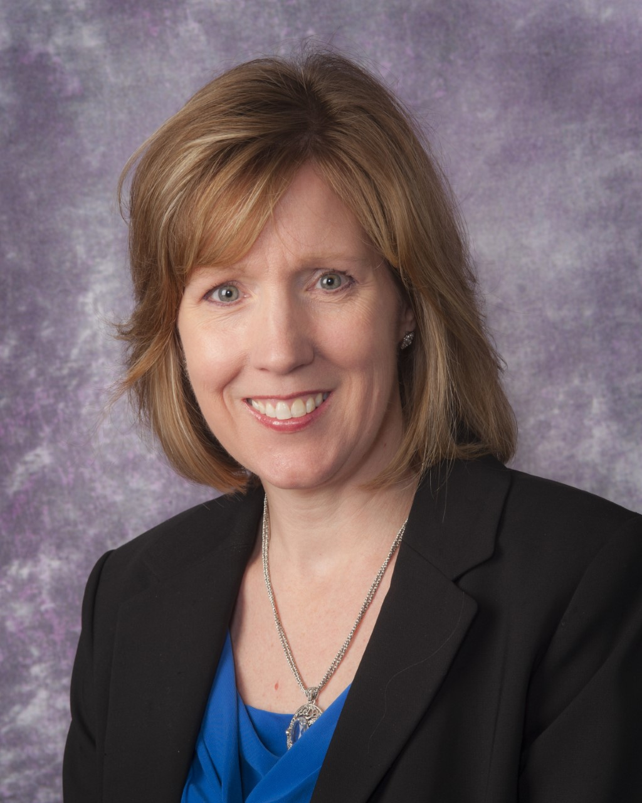
Anne Mucha is the Program Coordinator of Vestibular Rehabilitation for the University of Pittsburgh Medical Center Sports Concussion Program and the UPMC Centers for Rehab Services. She received her Bachelor’s and Advanced Master’s degrees in Physical Therapy from the University of Pittsburgh; and her Doctor of Physical Therapy degree from Temple University. Dr. Mucha is actively involved in clinical practice as well as research focused on vestibular and oculomotor assessment and treatment following mild TBI. She served as a member of the Centers for Disease Control panel of experts to develop clinical guidelines for diagnosis and management of mild TBI among children and adolescents. Dr. Mucha speaks national and internationally on concussion and vestibular/oculomotor disorders and is an adjunct faculty member in the School of Health and Rehabilitation Sciences at the University of Pittsburgh.

Kathryn Schneider, PT, PhD
Dr. Kathryn Schneider is an Assistant Professor and Clinician Scientist in the Faculty of Kinesiology at the University of Calgary and a physiotherapist at Evidence Sport and Spinal Therapy. Her research focuses on the prevention and treatment of concussion, with a focus on the role of the cervical spine and vestibular systems. She was the lead author of a randomized controlled trial evaluating the effects of multimodal physiotherapy and vestibular rehabilitation in athletes who have sustained a sport-related concussion. This study identified a significant treatment effect in the individuals who were treated with this therapy.
Kathryn was an invited speaker at the 4th International Consensus on Concussion in Sport in Zurich, Switzerland, November 2012 as well as an author of the consensus statement. In November of 2012, she was selected one of Avenue Magazine’s “Top 40 Under 40”. She was also an invited speaker (via video presentation) to the Sochi Olympic Winter Games Medical Meetings, February, 2014.
Dr. Schneider is a Clinical Specialist in Musculoskeletal Physiotherapy. She has completed her Advanced Diploma of Manual and Manipulative Therapy (2004) and a certification program in Vestibular Rehabilitation (Emory University, 2003), an Advances In Vestibular Rehabilitation certification (Duke University, 2009), and a Doctor of Science degree (DSc) (Andrew’s University) (2008). She has developed and taught multiple courses on Vestibular Rehabilitation, Sport Related Concussion and Whiplash Associated Disorders.

Karen Lambert, PT, DPT, NCS
Karen H. Lambert, P.T., D.P.T., N.C.S. currently serves as the Vestibular Program Manager for the Hearing Center of Excellence (HCE) for the Department of Defense (DoD) and Veterans Administration (VA). In addition, she provides clinical care at a private outpatient physical therapy clinic specializing in the treatment of patients with neurologic dysfunction. She earned a Master of Physical Therapy from Medical College of Pennsylvania (MCP) Hahnemann University in 2000 and her Doctorate of Physical Therapy from Drexel University in 2014. She received Board Certification in the area of Neurologic Physical Therapy from the American Physical Therapy Board of Clinical Specialties in 2006 and recertification in 2016. She has served on multiple task forces related to concussion and vestibular dysfunction for the Academy of Neurology within the American Physical Therapy Association. She served as the Officer in Charge of the Traumatic Brain Injury Section of Physical Therapy at Walter Reed Army Medical Center from December 2007-August 2010 where she participated in several research projects aimed at investigating the most effective rehabilitative techniques for service members with complaints of dizziness and/or cognitive impairment post mild to moderate traumatic brain injury.

Alexander G. A. Ring, PT
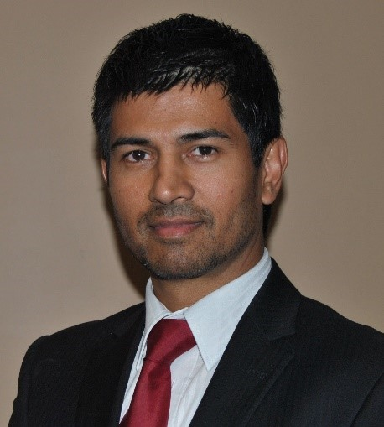
Alexander G.A. Ring, BPT, APAM is a Physiotherapist from Perth, Western Australia. He graduated from the Christian Medical College - University of Madras in 1988 and then completed his AECOP through the Australian Physiotherapy Council in 1993. Mr Ring runs dedicated clinics 4 days a week in the areas of Concussion, Balance and Vestibular disorders. He is an Adjunct Research Fellow with the School of PT, Curtin University and Murdoch University, Western Australia. His current research looks at exercise exertion protocols and oculomotor/VOR dysfunction in Concussion. He is the Co-Chair of the Western Australian Concussion Network.

Raymond Van der Berg, MD

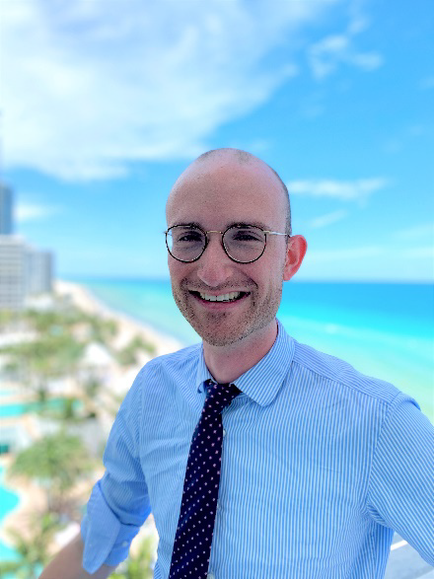

Raymond van de Berg was born on September 5th, 1984 in Geldrop, The Netherlands. He studied Medicine at the University of Maastricht from 2002 until 2008. Directly after graduation he started his residency in Otorhinolaryngology starting at the Department of Otolaryngology and Head and Neck Surgery in Maastricht until 2013. He currently works as an Associate Professor and ENT-surgeon at Maastricht University Medical Center, with a special interest in vestibular disorders. His research initiatives mainly focus on the vestibular implant, bilateral vestibulopathy and vestibular diagnostics. He obtained his PhD (in medicine) cum laude, which won several scientific prizes. He is also head of the Department of Audiology, Head of the Vestibular Department and Assistant Professor at the Faculty of Physics in Tomsk, Russia.

Thomas Lempert, MD
Thomas Lempert is Professor of Neurology at Charité University Hospital and Head of Neurology at Schlosspark-Klinik in Berlin, Germany. He spent most of his professional life at Charité University Hospital as a general neurologist and neuro-otologist. He learnt to treat dizzy patients a research at the University Hospital in Munich (Prof. Thomas Brandt) and later at the MRC Movement and Balance Unit in London (Prof. Adolfo Bronstein and Prof. Michael Gresty). He heads the Vestibular Migraine Group of the Classification Committee of the International Bárány Society.

Klaus Jahn, MD
Klaus Jahn was educated at the Medical Schools of the University of Duisburg-Essen, the Technical University of Munich, Germany, and at the University of Wisconsin, Madison, WI, USA. He received his medical degree in 1996. For his MD thesis he investigated ligand-activated ion channels in thin brain slices using patch-clamp electrophysiology. He received training in Neurology at the Technical University of Munich (TU) and at the Ludwig-Maximilians University of Munich (LMU) and became board certified Neurologist and Intensive Care specialist in 2005. In 2006, he received his habilitation degree in Neurology and Clinical Neurophysiology in Munich (LMU). The topic of his research thesis was the relation of balance control and eye movements. The same year he received the Richard Jung Award from the German Society of Clinical Neurophysiology and Functional Imaging (DGKN) for his work on balance and gait control. Klaus Jahn has been Consultant Neurologist at the University of Munich (LMU) 2006-2014. In 2009 he was among the initiators for an innovative unit for research and treatment, the German Center of Vertigo and Balance Disorders (DSGZ). He has been the director of this interdisciplinary center from 2012-2014. In 2015 he became Medical Director of the Schoen Clinic Bad Aibling, one of Europe’s largest centers for Neurorehabilitation. He currently also holds a research position as head of Neurorehabilitation at the DSGZ (LMU Munich). Klaus Jahn published >200 original articles in international peer reviewed journals and contributed to numerous books and educational programs. His research focus is on balance, gait disorders, vertigo & dizziness, and neurorehabilitation.

Janene Holmberg, DPT, NCS
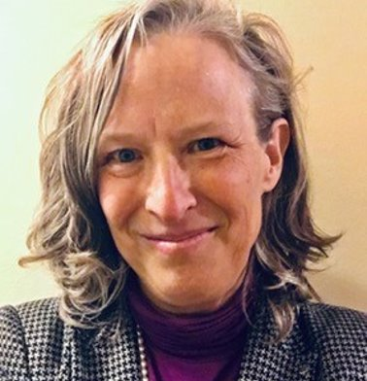
Janene M. Holmberg, PT, DPT, NCS graduated from the University of Utah with her entry level PT degree in 1987 and then in 2009 with her DPT. She has specialized in vestibular rehabilitation and helped to establish and build Intermountain’ s Hearing and Balance Center in Salt Lake City, Utah. She has over 30 years of experience treating wide variety of patients with vestibular and neurologic dizziness/balance problems. Dr Holmberg serves as faculty at the annual, internationally respected, Vestibular Competency Course (Drs Susan Herdman and Richard Clendaniel, directors) and has been integral in establishing and teaching balance/vestibular courses in the physical therapy schools of the University of Utah, Rocky Mountain University of Health Professionals, and Las Vegas (UVLV). She lectures nationally and internationally in the field of vestibular and balance rehabilitation with many leaders in the field at conferences, conventions and has presented numerous two-day courses in advanced vestibular/balance topics. She frequently presents educational sessions at national conventions and has been the keynote speaker in multiple state professional conferences. Dr. Holmberg was awarded Physical Therapist of the Year by the Utah Chapter APTA in 2001 for her specialty work in vestibular/balance rehabilitation and in 2014 received the Clinical Excellence in Neurology Award from the Neurology Section of the APTA. Dr Holmberg has served for years on the APTA Neurology Section's Vestibular Special Interest Group, advocating for the increased expertise and impact of vestibular rehabilitation. She was invited to serve as content expert for the Neurology section’s Vestibular Specialization Task Force (2014) and the interdisciplinary, Otolaryngology Head Neck Surgery BPPV Clinical Practice Guideline (CPG) panel, that revised and published the updated BPPV CPG in 2017. She is published in areas of BPPV, clinical updates on vestibular rehabilitation, and most recently in area of chronic dizziness secondary to functional/psychiatric disorders, specifically the diagnosis of Persistent Postural-Perceptual Dizziness (PPPD). She is currently working in a leadership position for Intermountain Rehabilitation Services where she fosters collaboration, best evidence care, clinical research and mentoring in addition to keeping a small clinical practice at the Hearing and Balance Center. She is respected skilled clinician and has mentored many in her field of expertise to better manage the complexities of the dizzy and unsteady patient.

Francisco Carlos Zuma e Mia, MD, PhD
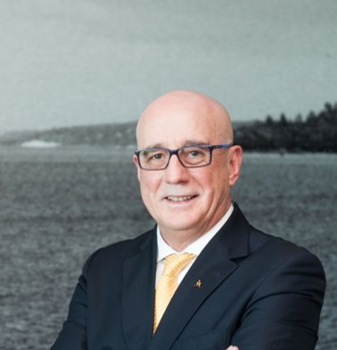
Francisco Carlos Zuma e Maia received his degree in Medicine from the School of Medicine and Surgery of Rio de Janeiro (1973), specialization in Otorhinolaryngology and Otoneurology in Strasbourg (France), Master and Doctorate in Medicine from the Federal University of Rio Grande do Sul. Currently he is Preceptor in Neurotology at Pontifícia Universidade Católica do Rio Grande do Sul (PUC-RS); Member of the Barany Society and the Ibero-American Neurotology Foundation (FINO). Member of the Brazilian Academy of Military Medicine; Member of the Research Group in Otology and Otoneurology at HCPA / CPPq. He is a retired medical Lieutenant Colonel in the Brazilian Air Force. He is author and co-author of three books of Neurotology and over 14 articles in MEDLINE. Acting mainly on the following themes: Vestibular Syndromes: VPPB, Meniere and Vestibular Neuritis.

Dario Yacovino, MD
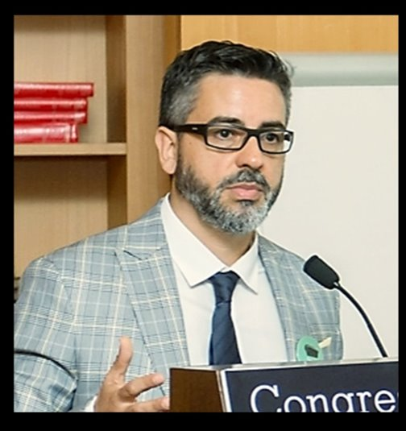
Dario Yacovino, MD, PhD is a board-certified neurologist (Ministry of public Health and Buenos Aires University, Argentina), with 20 years of experience in the treatment of neurology and neuro-otology patients. He completed a Postdoctoral Clinical Fellowship in Neuro-otolgy, Physical Therapy/Human Movement Science at Northwestern University Medical School, Chicago IL, USA (2003-2004). In 2014 he was Secretary of the Barany Meeting in Buenos Aires. For more than 10 years he was a staff member of the Neurological Research Institute “Raúl Carrea” (FLENI) Neuro-Otology Department in Buenos Aires, Argentina. Currently, he is a professor of Clinical Neurology at the Medical school of Buenos Aires University and an enthusiastic teacher of Post Graduated Vestibular and balance rehabilitation annual course (AAK). Professor Yacovino is Deputy chief of the Neurology Department at the Dr. Cesar Milstein Hospital, Buenos Aires and Head of the Buenos Aires Dizziness and Memory disorders Clinic. He has written over twenty indexed papers and six book chapters on clinical and basic aspects of vestibular disorders and a similar number of papers for local journals. He has acted as reviewer in several journals in the vestibular field. His current research interests include atypical variants of benign positional vertigo and new clinical aspects of vestibular disorders.

Jeffrey Staab, MD
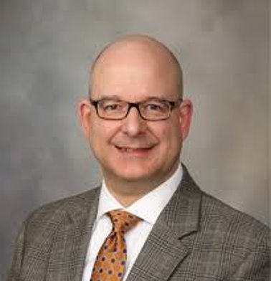
Jeffrey P. Staab, MD, MS received his MD from the University of Pittsburgh and MS in bioengineering from Carnegie-Mellon University. He completed an internship in internal medicine and residency in psychiatry at the National Naval Medical Center (now Walter Reed National Military Medical Center) in Bethesda, MD. Currently, Dr. Staab is Professor and Chair of the Department of Psychiatry and Psychology and Director of the Fellowship in ConsultationLiaison Psychiatry at Mayo Clinic, Rochester, MN. He is author or co-author of over 140 scientific articles, reviews, and chapters and serves on the editorial boards of six scientific journals in the fields of psychosomatic medicine and otorhinolaryngology. His current research uses psychological, physiological, and brain imaging to investigate various types of chronic dizziness, including persistent postural-perceptual dizziness (PPPD) and post traumatic dizziness.

Megan Kenney, OTR/L
Megan Driscoll is an occupational therapist who graduated from the University of Pittsburgh’s School of Health and Rehab Science Occupational Therapy program in 2012. She currently works with UPMC Centers for Rehab Services as chronic pain program director, and assistant outpatient occupational therapy program director. Megan also works with Pitt’s OT department as an adjunct instructor. Megan has specialized in chronic pain management for eight of her ten years as a clinician, and in that time has developed multiple educational courses for students, staff and practitioners; developed a comprehensive occupational therapy chronic pain program offered at ten outpatient sites; and has participated in numerous chronic pain conferences and meetings at the national level. Megan has published several papers related to OT’s role in chronic pain management and has received awards related to her role in education and advocacy for Occupational Therapist’s in chronic pain including the Occupational Therapy Alumni Award of Excellence from the University of Pittsburgh, the OT Award of Recognition from POTA, and the Distinguished Alumni Award from the University of Pittsburgh. Megan is also active in chronic pain research and has acted as lead therapist and principal investigator on studies related to chronic conditions.

Julie Maggio, PT, DPT, NCS
Julie received her DPT from Quinnipiac University. She is currently the Neurologic Clinical Specialist for outpatient physical therapy at Mass General Hospital where she oversees neurologic clinical practice. In addition, she is an affiliated researcher with the MGH Functional Neurology Research Group. She works exclusively with patients who have neurologic dysfunction and has extensive experience treating patients with Functional Neurological Disorders (FND). Her research is focused on outpatient care of FND and she actively lectures on physical therapy for treatment of FND. Julie is a founding member of the FND society and is recognized as a Certified Neurologic Clinical Specialist by the American Board of Physical Therapy Specialties.

Sharon Cushing, MD. M.Sc. FRCSC
Dr. Sharon Cushing is a full-time paediatric otolaryngologist at The Hospital for Sick Children in Toronto, Canada, and an Associate Professor and Clinician Investigator in the Department of Otolaryngology Head and Neck Surgery at the University of Toronto. She is the Director of the Cochlear Implant Program at the Hospital for Sick Children. Dr. Cushing has a clinical and surgical interest in disorders of the external, middle and inner ear, including hearing loss and vestibular dysfunction. Her research interests include vestibular and balance function and dysfunction in children, and its association with hearing loss and cochlear implantation.
Dr. Cushing completed her undergraduate degree at Queen’s University in Kingston, followed by Medical School and Residency training in Otolaryngology Head and Neck Surgery at the University of Toronto. In addition, Dr. Cushing completed a Master’s in Science degree examining vestibular function and balance in children with hearing loss through the Surgeon Scientist Program at the University of Toronto. She completed her fellowship training in Paediatric Otolaryngology at Seattle Children’s Hospital prior to returning to Sick Kids in Toronto.

Diego Kaski, MD, PhD
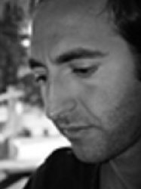
Diego Kaski is an international leader in Vestibular Neuroscience, with major publications in high-impact journals, including Nature Genetics, BMJ, Lancet Neurology, and Annals of Internal Medicine. He set up and heads the Centre for Behavioural and Vestibular Neurosciences within the Department of Clinical and Motor Neurosciences at UCL and leads an active group of research exploring the neural mechanisms of spatial orientation and multisensory integration, with a strong translational element that aims to develop novel clinical biomarkers and therapies for vestibular disorders. He received the EAN Young Investigator award in 2015 and Barany Society Young instigator award in 2014. He has over 120 peer-reviewed research publications and 8 book chapters in English and Spanish languages. As a marker of the prestige surrounding his unit, he welcomes regular International visiting fellows, and receives frequent invitations to take part in International conferences, seminars and masterclasses.

Marousa Pavlou, PT, PhD
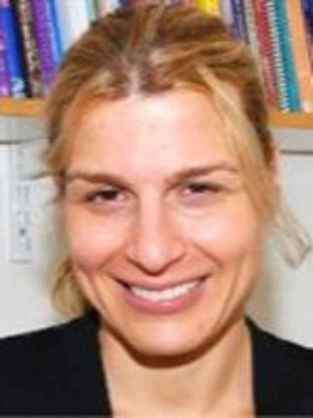
Dr Marousa Pavlou is a Senior Lecturer of Physiotherapy at King’s College London. Her research work focuses on how the human sensory and motor systems react, interact, and adapt to everyday as well as novel challenges in health and disease, and how these responses are affected by the ageing process. The aim is to apply this knowledge to develop precision interventions in vestibular, falls, and stroke rehabilitation that will provide further improvements in symptoms, postural stability, quality of life, and falls risk compared to current practice. She has published numerous articles as well as book chapters and has been invited to present her work at various NHS physiotherapy, neurology, and audiology departments, teaching seminars, and at many national and international conferences. Dr Pavlou is a member of the Chartered Society of Physiotherapy, the International Society for Posture and Gait Research, an elected member of the International Bárány Society and is past-chairman of the Association of Chartered Physiotherapists interested in Vestibular Rehabilitation.

Yuri Agrawal, MD, MPH, FACS
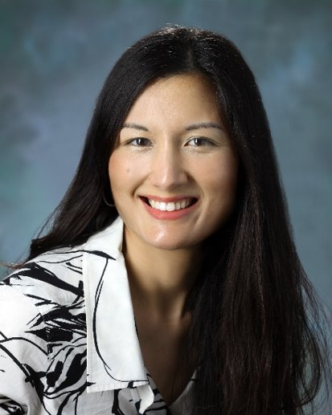
Dr. Yuri Agrawal is an Neurotologist-Skull Base Surgeon whose practice is focused on the medical and surgical treatment of ear, hearing and balance disorders. She sees patients for a range of conditions including hearing loss, deafness, otosclerosis, cholesteatoma, skull base tumors, acoustic neuromas and vestibular (inner ear balance) disorders. She directs a research program focused on studying age-related changes in vestibular function, and her group’s work is funded by several NIH and foundation grants.

Brooke Klatt, PT, PhD, NCS
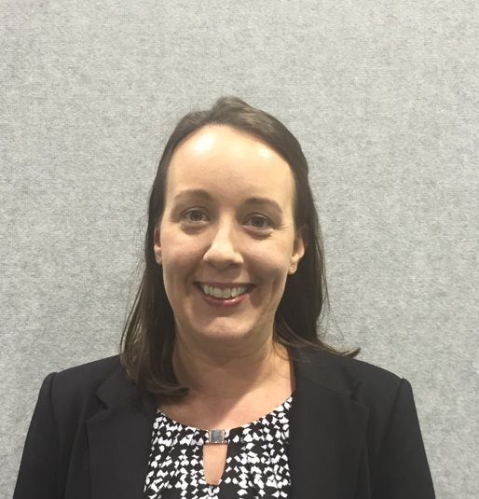
Brooke N. Klatt, PT, DPT, PhD is an Assistant Professor in the Physical Therapy Department at the University of Pittsburgh. She received her BS in Kinesiology from Penn State University; DPT from New York University; PhD in Rehabilitation Science from University of Pittsburgh; and completed a post-doctoral fellowship at Johns Hopkins University. During her post-doctoral fellowship, she investigated the interplay between vestibular and cognitive function. Dr. Klatt continues to investigate this line of research and in addition to cognition, is interested in exploring other factors that are associated with activity and participation in people with vestibular disorders. Dr. Klatt has received support from the National Institutes of Health and the Department of Defense to conduct her research aiming to optimize vestibular rehabilitation delivery and outcomes.

Colin Grove, PT, PhD, NCS
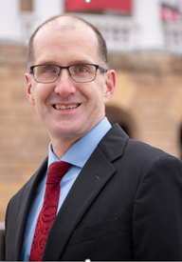
Colin R. Grove, PT, DPT, PhD received his academic doctorate in Clinical Investigation from the University of Wisconsin-Madison and his clinical doctorate in physical therapy from Temple University in Philadelphia, PA. At present, he is a postdoctoral fellow in the Department of Kinesiology at the University of Wisconsin-Madison. His research interests involve understanding the sensory and perceptual challenges to balance and gait in persons with labyrinthine dysfunction. Dr. Grove is a Board-certified Specialist in Neurologic Physical Therapy. For the past 27 years, he has practiced neurologic and vestibular physical therapy at the University of Wisconsin Hospital and Clinics.

Janet Helminski, PT, PhD
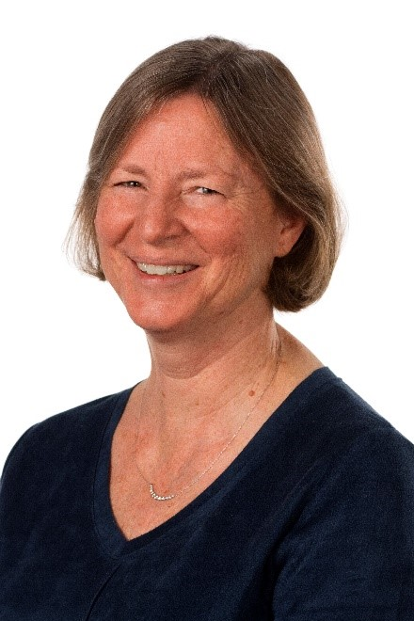
Janet O. Helminski, PT, PhD received her PhD in Neurobiology and Physiology from Northwestern University’s Institute of Neuroscience, MS in Physical Therapy from Northwestern University and her physical therapy education from Marquette University. Currently she is a Professor in Physical Therapy, in the College of Health Sciences, Midwestern University and Physical Therapist at Midwestern University’s Multispecialty Clinic specializing in vestibular rehabilitation. Her current areas of research include management of atypical BPPV and uncompensated unilateral peripheral vestibular hypofunction. She lectures extensively on vestibular rehabilitation. She received the 2015 American Physical Therapy Association Jack Walker Award and 2013 Best Article Award from the Vestibular Special Interest Group of the Academy of Neurologic Physical Therapy for her articles on typical and atypical BPPV.

Michael Schubert, PT, PHD, FAPTA
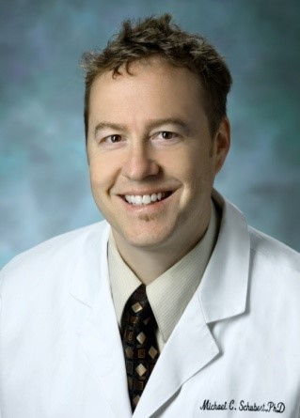
Dr Schubert is Professor in the Department of Otolaryngology Head and Neck Surgery with a joint appointment in Physical Medicine and Rehabilitation at The Johns Hopkins University School of Medicine. He completed his PhD at the University of Miami and a post-doctoral fellowship at Johns Hopkins University. His clinical focus is treating gaze and gait instability in people with loss of vestibular sensation. His current research investigates differences in motor learning in the vestibulo-ocular reflex using different types of error signals. In addition, he is conducting a clinical trial using novel equipment to improve the vestibulo-ocular reflex.

Regan Harrell, PT, DPT, NCS
Regan Harrell, PT, DPT, Board Certified Neurological Clinical Specialist: Regan graduated with her Doctorate in Physical Therapy from Duquesne University in 2015. After working in a small community-based hospital in Seattle, WA, she completed a neurological residency program with UPMC in Pittsburgh PA in 2018. She now works full time staff member at UPMC Rehab Institute working on the Brain Injury Unit and continues teaching in the clinical neurological coursework in the physical therapy programs of the University of Pittsburgh and Duquesne University. She is also a faculty member of the UPMC Neurologic Residency program and a course coordinator for the University of Pittsburgh’s Advanced Vestibular Physical Therapist Certification Program.

Patrick Sparto, PT, PhD, FAPTA
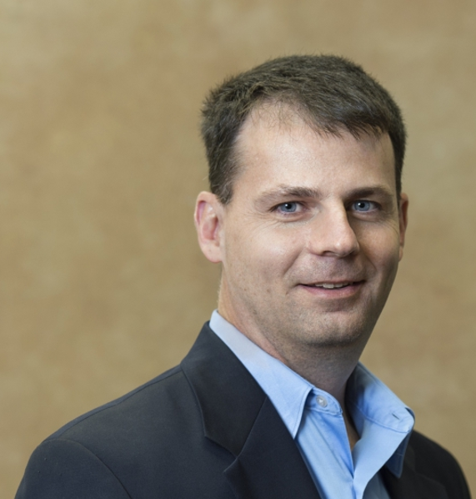
Patrick Sparto is a Professor in the Departments of Physical Therapy, Otolaryngology and Bioengineering. Dr. Sparto received his Ph.D. degree from Ohio State University in 1998 and completed Master of Physical Therapy degree at the University of Pittsburgh in 1999. He is the founding Co-Director of the DPT-PhD in Bioengineering program at Pitt. He works at the Centers for Rehab Services Vestibular Rehabilitation clinic and is active in the Academy of Neurologic Physical Therapy. Dr. Sparto's fields of interest include neuroimaging of balance and vestibular function, and management of vestibular disorders after concussion. Dr. Sparto has published over 100 refereed articles and has received funding from the NIH, and Department of Defense.

Julie Treleaven, PhD, BPhty
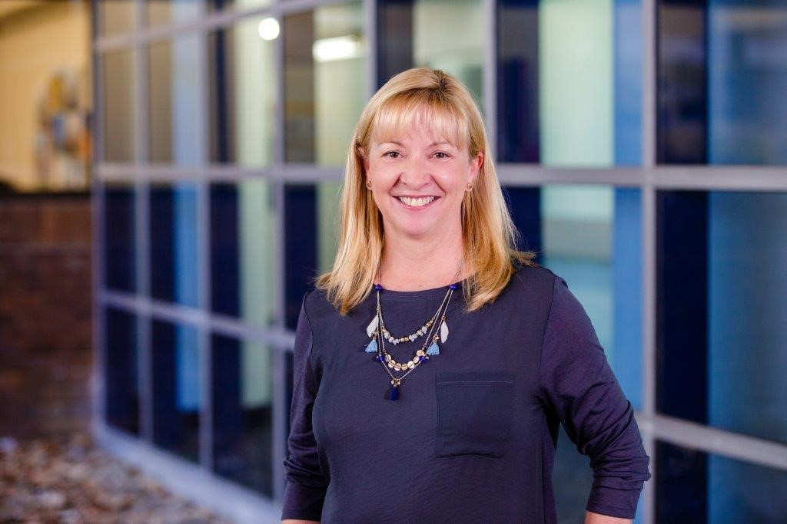
Julia Treleaven is a Lecturer and Senior Researcher at the University of Queensland. In 2004 she completed her PhD focusing on the neck's influence on dizziness, head and eye movement control and postural stability in whiplash injuries. Her research continues in this area and has looked at the cervical sensorimotor control in idiopathic neck pain, the elderly and post-concussion. She is particularly interested in identifying clinical measures to assist with differential diagnosis of cervicogenic dizziness. She has published over 90 peer reviewed papers and has contributed to several book chapters and is author of the recent book Management of neck disorders- An evidenced based approach. Julia also works part-time in private practice assessing and treating patients such as those with whiplash, cervicogenic dizziness and headache and post-concussion syndrome.

