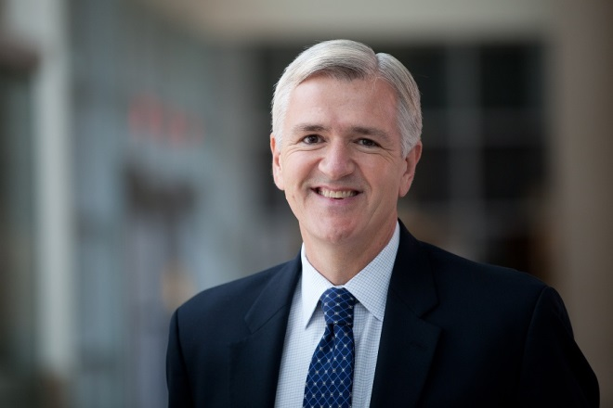
Professor Everette James serves as Director of the University of Pittsburgh’s Health Policy Institute (HPI). He is also Associate Vice Chancellor for Health Policy and Planning, Schools of the Health Sciences, and the M. Allen Pond Professor of Health Policy and Management in the Pitt Graduate School of Public Health. Everette has a secondary appointment as Professor in the Department of Physical Therapy.
Before joining Pitt, Everette served as the 25th Pennsylvania Secretary of Health and oversaw the regulation of all of the hospitals, nursing homes and managed care plans in the Commonwealth. He was responsible for managing the Department of Health’s 1700 employees and $1b annual budget, and chaired and served on many statewide boards and commissions including the Pennsylvania Health Policy Board, Health Research Advisory Committee and the Children’s Health Advisory Council.
As Senior Advisor to Governor Rendell for Health and Pensions and then Secretary of Health, he formulated policy, drafted and negotiated legislation and implemented laws and regulations including the state’s first indoor smoking ban (Clean Indoor Air Act), healthcare-associated infection law (Act 52), regulations expanding health professionals’ scope of practice and new nutrition and physical activity standards for Pennsylvania school children aimed at reducing the prevalence of childhood obesity.

Prior to his service to the Commonwealth of Pennsylvania, James was a partner in the Washington, D.C office of the Dewey, LeBoeuf law firm with a practice centered on insurance and healthcare corporate and regulatory matters. He also served as Deputy Assistant Secretary for Service Industries and Finance at the U.S. Department of Commerce.
Professor James’ research interests center around his state and federal public policy experience in health law and regulation, comparative effectiveness and translational health services research. He publishes frequently in Health Affairs, Forbes and JAMA on issues related to healthcare business and regulation. His most recent study “Addressing the Needs of Caregivers at Risk: A New Policy Strategy” proposes a comprehensive national policy approach to supporting U.S. families caring for elderly adults.

